Text classification 3

Source: https://people.ischool.berkeley.edu/~dbamman/nlp20_slides/4_classification_3.pdf
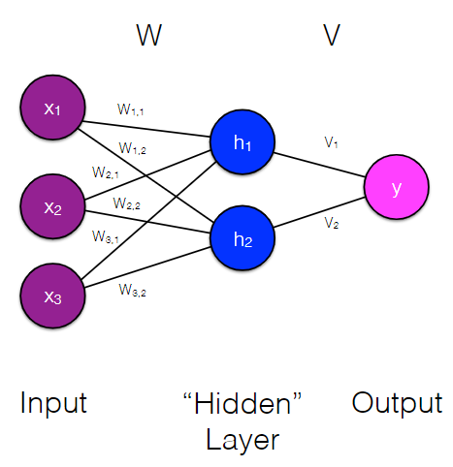
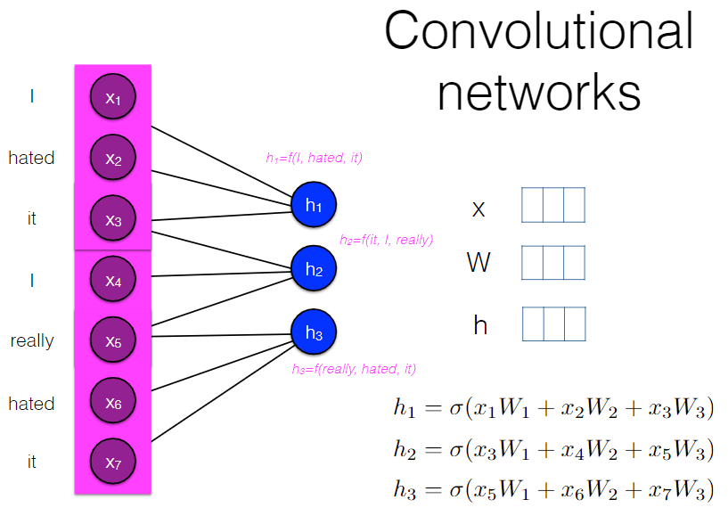
Neural networks
- Feedforward neural network

- Convolutional network
  - Window size adjustable

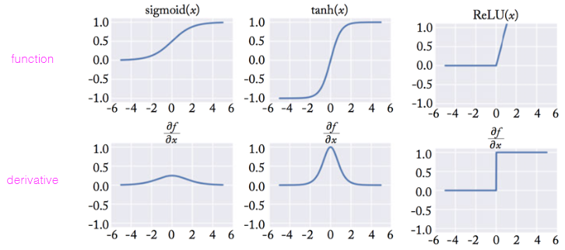
Activation functions
- Logistic (for final layer):
- tanh:
- ReLU:

Backpropagation
- Chain rule:

Regularization
- L1, L2, elastic net
- Dropout: randomly remove nodes/weights
- Early stopping: stop backpropagation before training error is too small

Max pooling
- Down-sample by taking max value from some set (select most important feature)
- Variations: global max pooling/max-pooling over time
- Filter: convolution layer + pooling layer

